|  |  |
| --- | --- |
| **Name:- Aryan Dilipbhai Langhanoja** | **Roll Number:- 92200133030** |
| **Subject Name and Code:-** Foundation Skills On Sensor Interfacing (01CT1103) | **Date of Experiment:- 18-12-2022** |

|  |  |
| --- | --- |
| Task:- |  |

Interface Soil moisture sesnor with arduino and turn on/off the pump as per the requirement.

|  |  |
| --- | --- |
| Components: |  |

* Arduino Uno R3
* LED
* Jumper Wires (Male To Male)
* Soil moisture Sensor
* Bread Board
* Soil moisture Sensor.
* Laptop Or PC

|  |  |
| --- | --- |
| About the Project:- |  |

* In thisproject, we are going to interface soil moisture sensor with Arduino. In this project, we will connect two parts of soil moisture sensor with female to female wire. After that, 4 points of other part, in that one is VCC which is connected to +5V of Arduino. Other pin is ground, which is connected to GND of the Arduino. One is A0 pin which is connected to Any of Analog pin. And one is D0 pin which is connected to any of Digital pin of Arduino.
* Soil moisture sensors **measure or estimate the amount of water in the soil**. These sensors can be stationary or portables such as handheld probes. Stationary sensors are placed at the predetermined locations and depths in the field, whereas portable soil moisture probes can measure soil moisture at several locations.

|  |  |
| --- | --- |
| Output:- (you circuit implementation) |  |

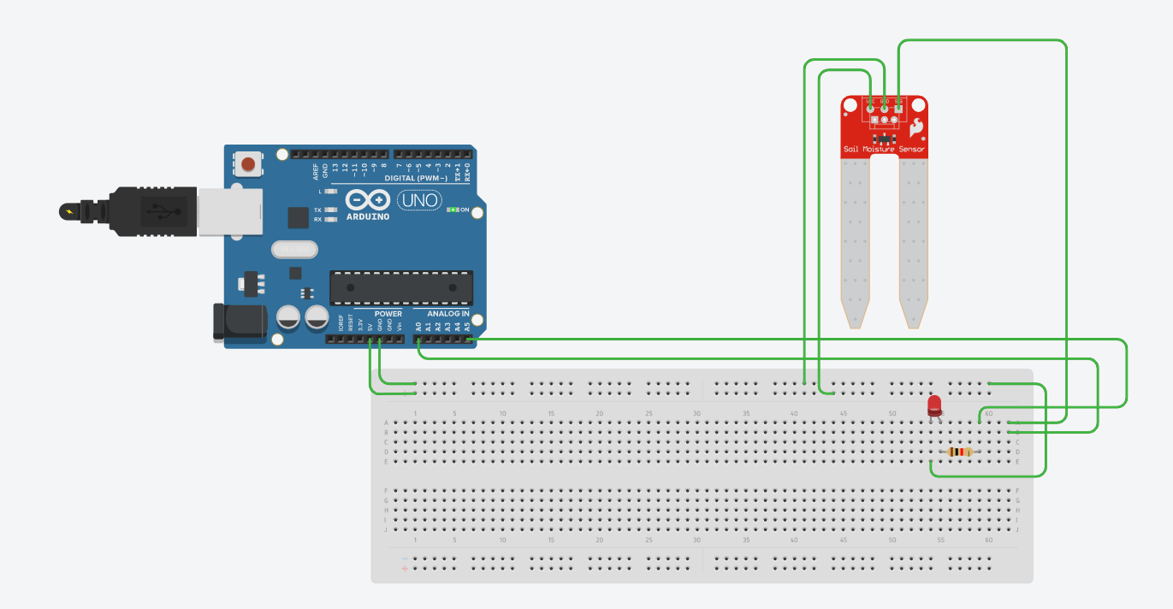

|  |  |  |
| --- | --- | --- |
| Schematic:- |  |  |

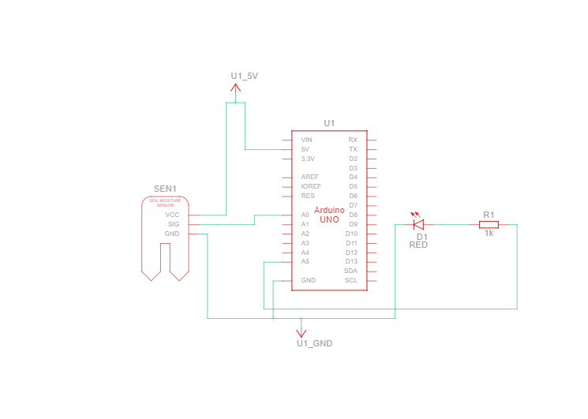

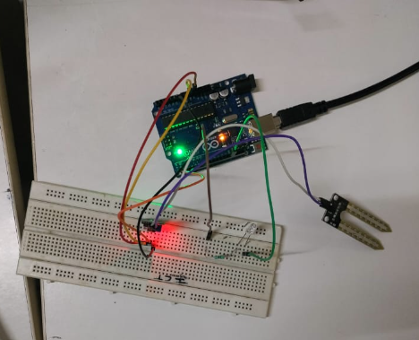

|  |  |
| --- | --- |
| Application:- |  |

|  |  |
| --- | --- |
| Code:- |  |

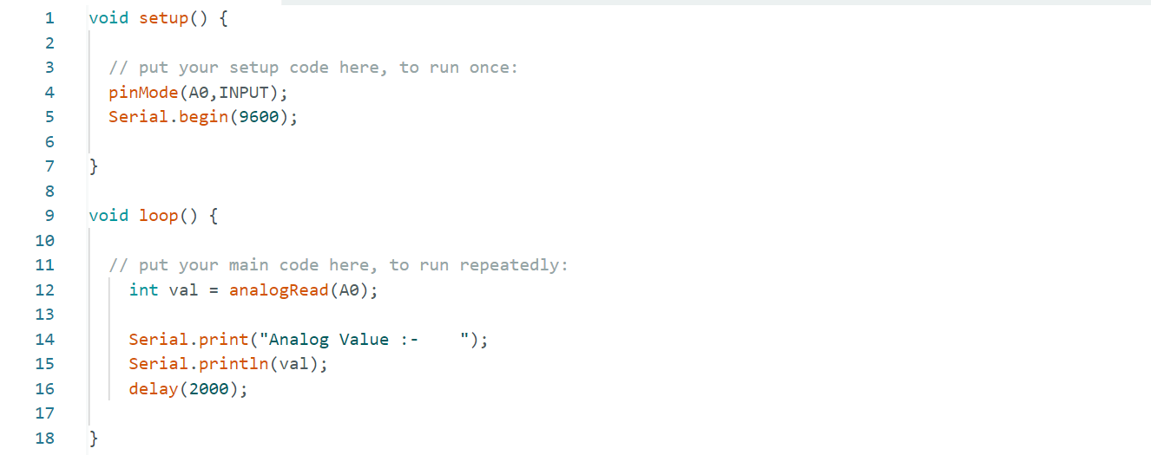

|  |  |
| --- | --- |
| Serial Monitor Reading:- |  |

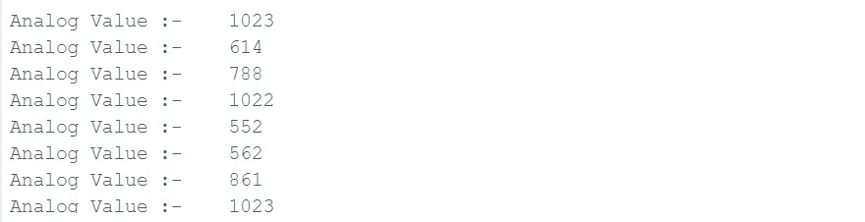

|  |  |
| --- | --- |
| Conclusion:- |  |

* In This Experiment, We Learnt That How To Interface Soil Moisture Sensor with Arduino.